19. Samba Server

Tasks

1. Install Samba on your Linux system and create a shared folder named 'music-share' that is accessible from Windows machines on your local network.

ANS:

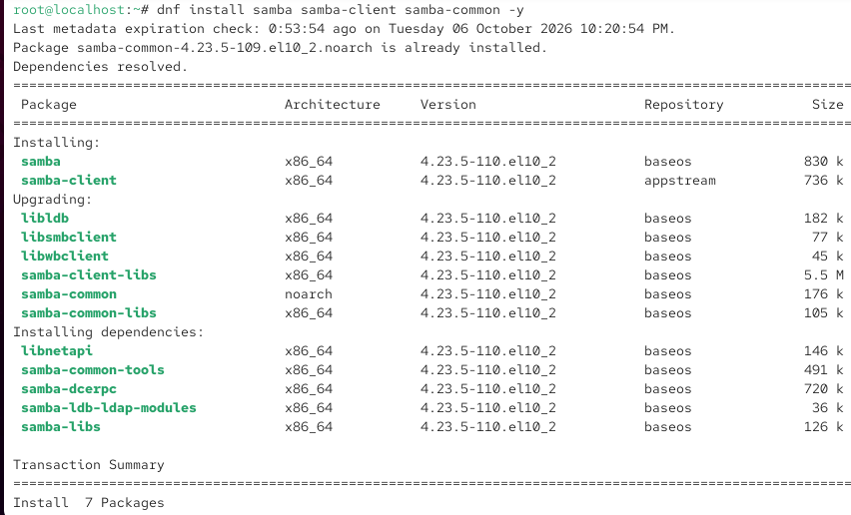

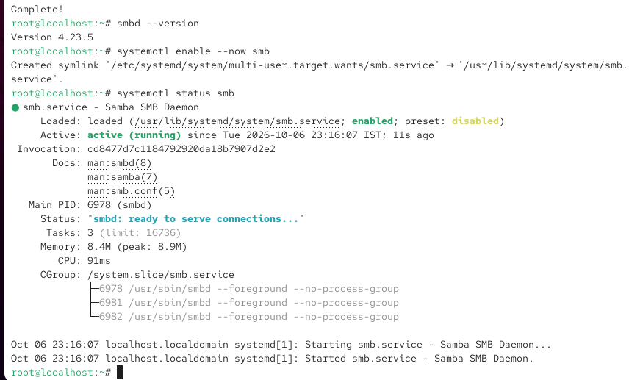

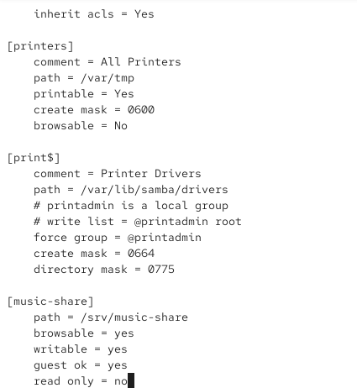
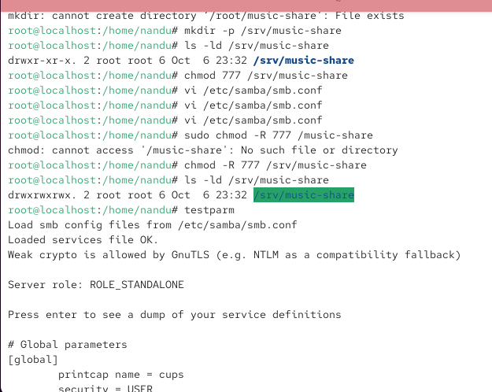

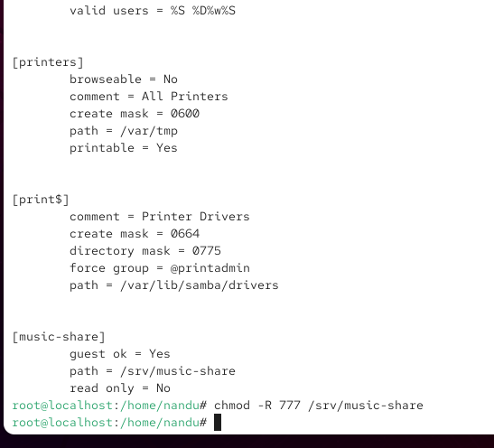

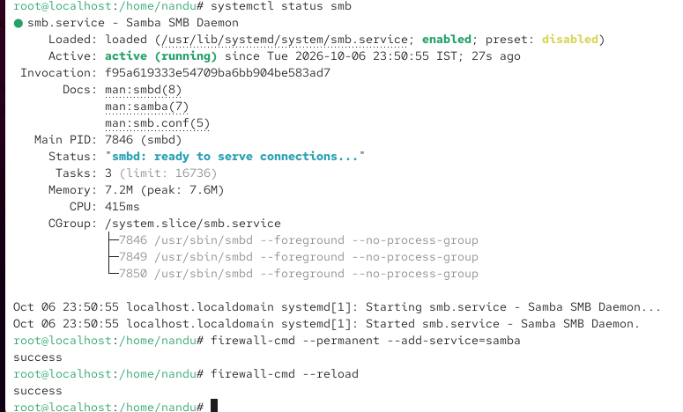

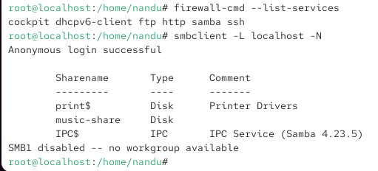

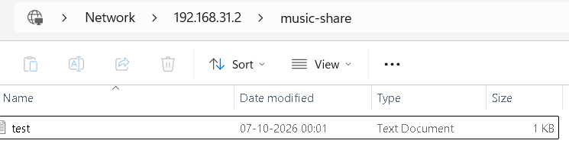

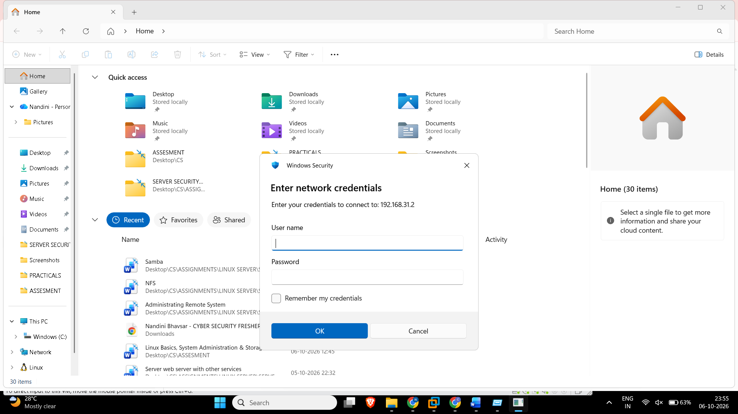

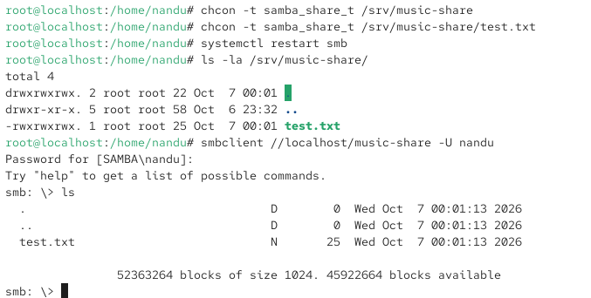

2. Configure Samba to allow only users 'partyuser' and 'guestuser' to access the 'music-share' folder, and set a Samba password for each user. Use the smbpasswd command to set Samba passwords after creating the Linux users.

ANS:

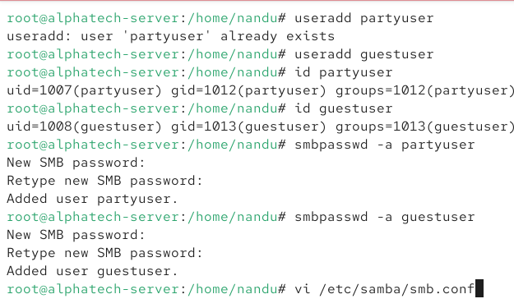

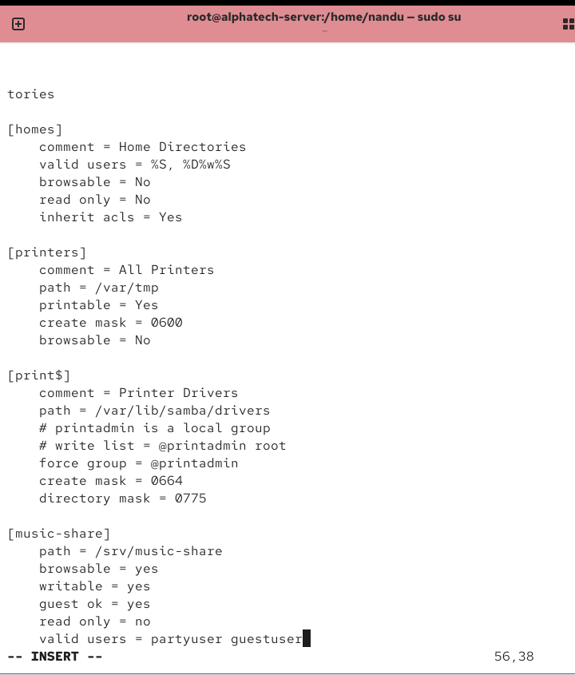

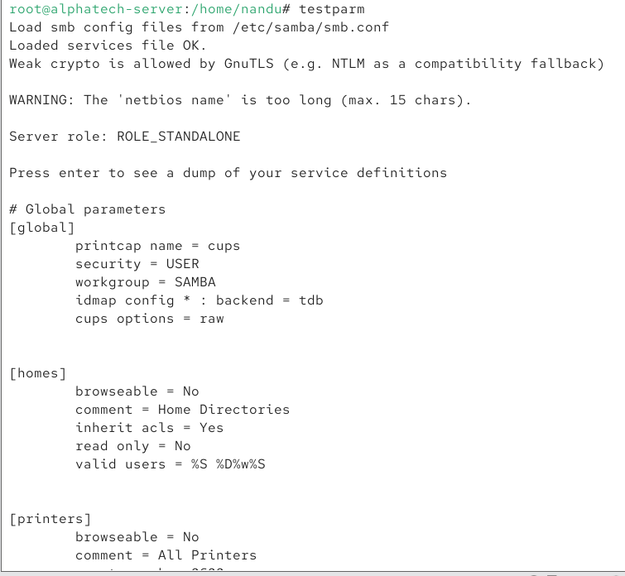

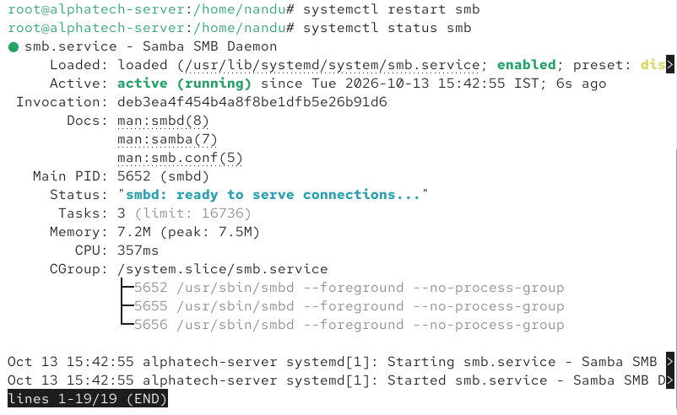

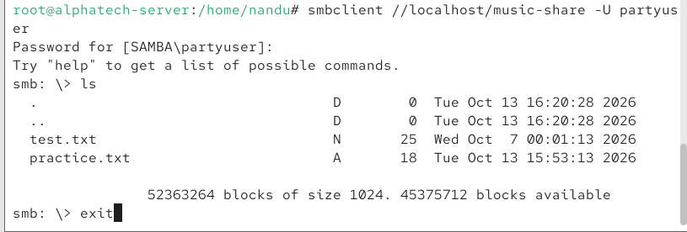

3. Edit the smb.conf file to make the 'music-share' folder read-only for 'guestuser' but read/write for 'partyuser'.

ANS:

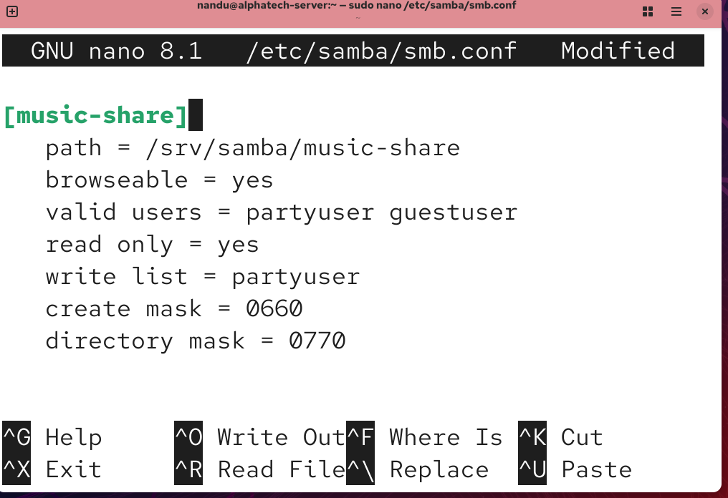

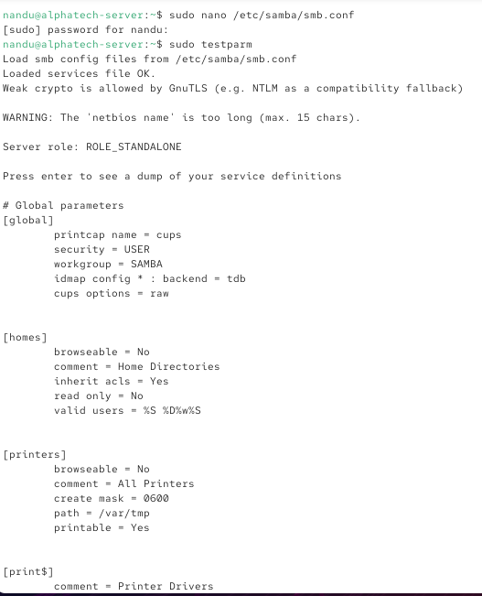

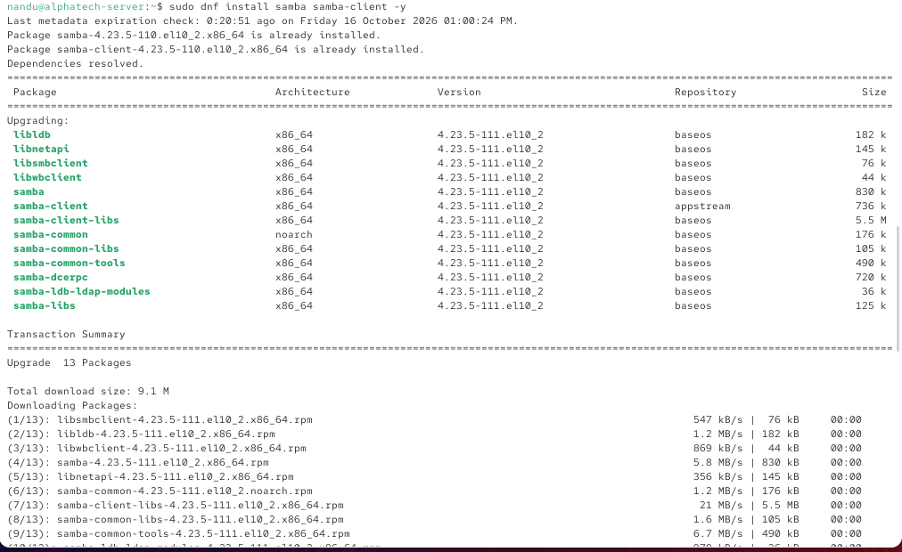
4. From a Windows machine or VM, connect to the 'music-share' Samba share using the 'partyuser' account and copy a sample MP3 file into the share. Then verify from Linux that the file appears in the shared folder.

ANS:

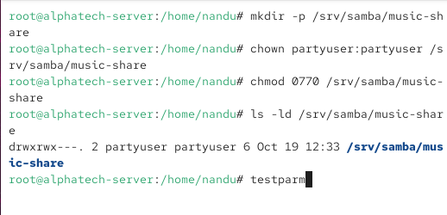

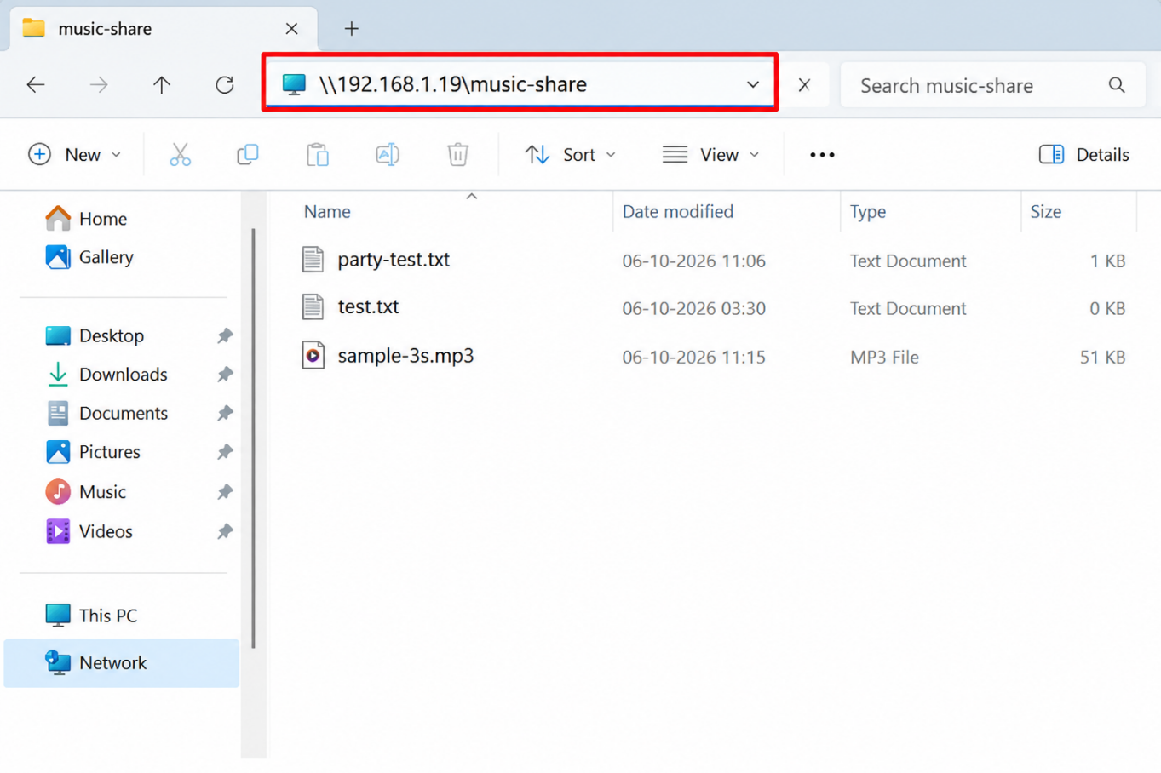

5. Restart the Samba service and use the smbstatus command to check if any clients are currently connected to your Samba share. If no clients are connected, try accessing the share from another device first.

ANS:

